**8.PROPOSED BLOCK DIAGRAM**

**8.1 Schematic Proposed Diagram of Combining Ac-Dc Transmission**



**Fig 8.1 Power Upgrading Of Combining Ac-Dc Transmission**

**Simulation Inverter model**

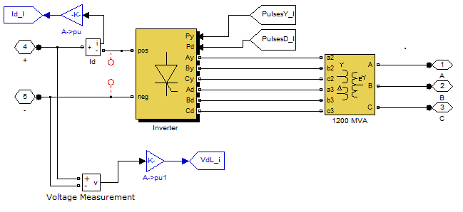

**Simulation model of rectifier**

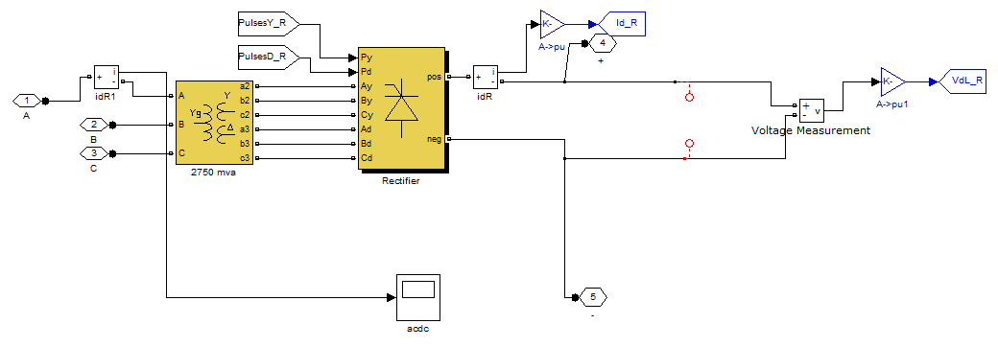

**Rectifier model simulation diagram**

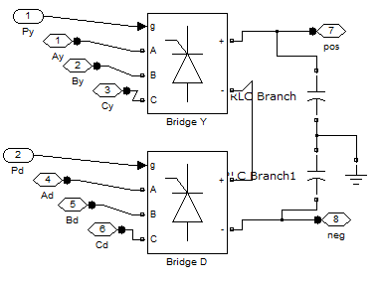

**Simulation diagram for filter**

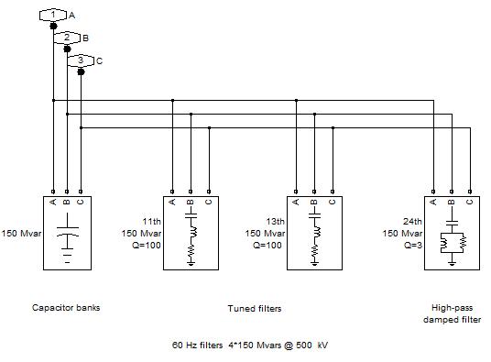

**Sub circuit for inverter model**

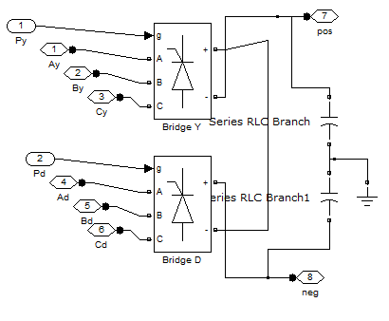

**RESULTS AND ANALYSIS**

**Three Phase Voltage Source Parameters**

|  |  |
| --- | --- |
| **Name** | **Value** |
| Phase-Phase RMS Voltage | 24KV |
| Phase angle of phase A | 0 |
| Frequency | 60Hz |

**Three Phase Harmonic Filter Parameters**

|  |  |
| --- | --- |
| **Name** | **Value** |
| Type of Filter | High Pass |
| Filter Connection | Y(grounded) |
| Nominal L-L Voltage | 24KV |
| Nominal Reacive Power | 500MVAR |
| Tuning Frequency | 24*60 |
| Quality Factor | 3 |

**Zig Zag Transformer Parameters**

|  |  |
| --- | --- |
| **NAME** | **VALUE** |
| Power | 2750MW |
| Frequency | 50Hz |
| Primary Voltage | 24KV |
| Secondary Voltage1 | 115KV |
| Secondary Voltage2 | 115KV |

**Distributed Parameters**

|  |  |
| --- | --- |
| **NAME** | **VALUE** |
| No.of Phases | 3 |
| Frequency | 50 |
| Resistance per unit length | [0.001273 0.03864] |
| Inductance per unit length | [0.9337e-3 4.1264e-3] |
| Capacitance per unit length | [12.74e-9 7.751e-9] |
| Length | 450KM |

**Three Phase Load Parameters**

|  |  |
| --- | --- |
| **NAME** | **VALUE** |
| Nominal Phase – phase Voltage RMS | 24KV |
| Frequency | 50Hz |
| Active Power | 2475MW |
| Inductive Reactive Power | 118.75e6MVAR |
| Capacitive Reactive Power | 0 MVAR |

**Universal Bridge Parameters**

|  |  |
| --- | --- |
| **NAME** | **VALUE** |
| No.of Bridge Arms | 3 |
| Snubber Resistance (Rs) | 2000 |
| Snubber Capacitance | 0.1e-6 F |
| Power Electronic Device | Thyristor |

**THREE PHASE TRANSFORMER (Three winding ) 1200 MVA rating ,wdg1,wdg2,wdg3:YG,Y,∆**

|  |  |
| --- | --- |
| **NAME** | **VALUE** |
| Nominal Power,Frequency | 2750MVA,50Hz |
| Winding1 | [ 24e3 0.0025 0 ] |
| Winding2 | [ 15e3 0.0025 0.24] |
| Winding 3 | [15e3 0.0025 0.24 ] |
| Magnetization Reactance | 500 |
| Magnetization Inductance | 500 |

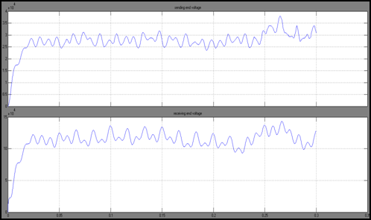

**Fig 8.1.1 Sending End Voltage-Receiving End Voltage Wave Forms**

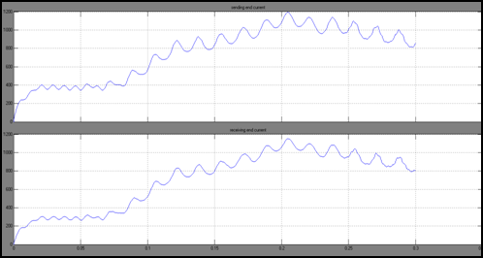

**Fig 8.1.2 Sending End Current-Receiving End Current Wave Forms**

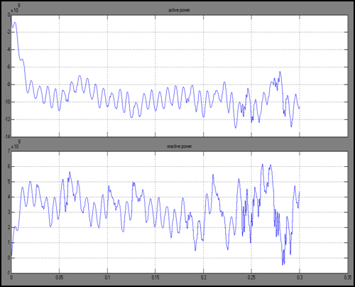

**Fig 8.1.3 Active And Reactive Power Wave Forms**

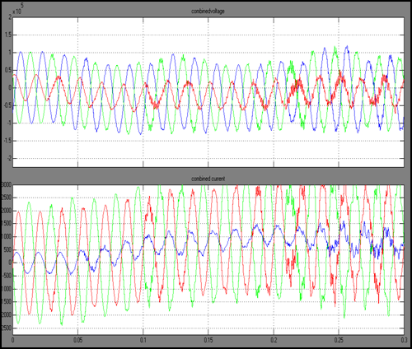

**Fig 8.1.4 Combined Ac-Dc Voltages And Currents Wave Forms**

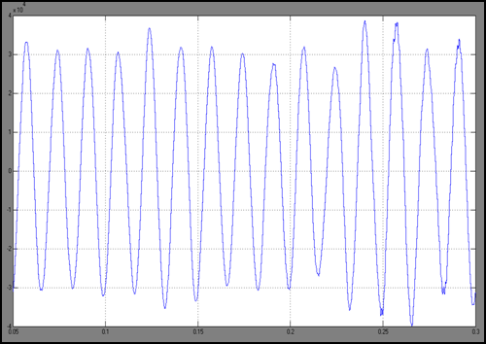

**Fig 8.1.5 Sending End Power Wave Form**

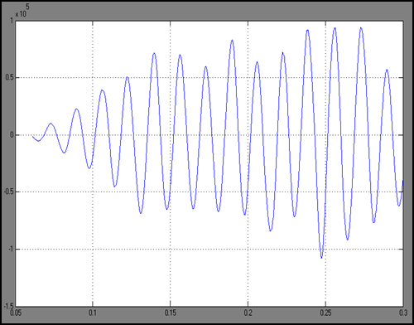

**Fig 8.1.6 Receiving End Power Wave Form**

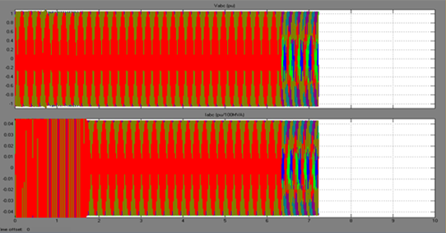

**Fig 8.1.7 Inverter Wave Form**

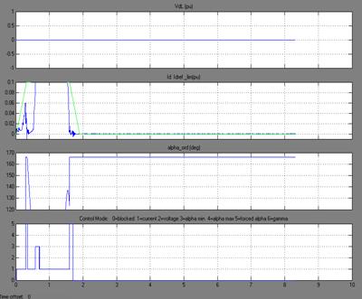

**Fig 8.1.8 Rectifier Wave Form**